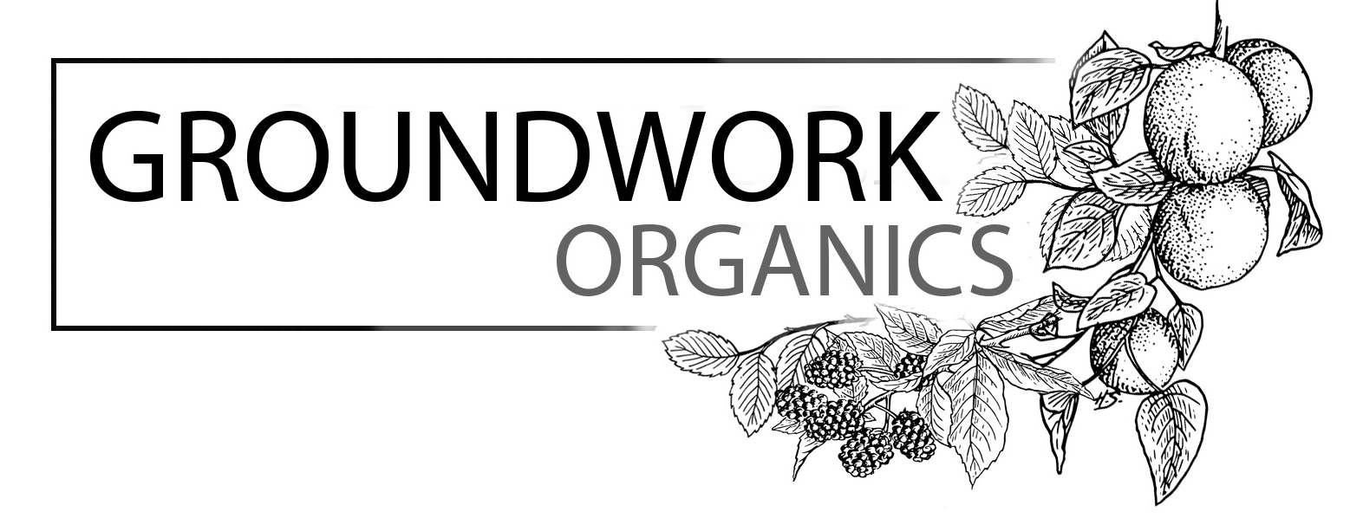
August 2, 2017

In your box

Red leaf lettuce
Cherry Tomatoes
Heirloom Tomatoes
Green Beans
Yellow Potatoes
Roma tomatoes
Basil
Walla Walla onion
Rainbow Chard
Plums

A little extra heat this week! Wow. Extra attention to watering new plantings in the field for the fall, and the whole crew starting at the break of day. We wanted to make this a nice big box with some ingredients for easy meals - pesto, blanched green beans, potato or nicoise salad. Plus lots of tomatoes ready for you, we had a whopper of a roma harvest and couldn’t resist including those too, some of the nicest we’ve ever grown. Great for sauce, and if you’re interested we’ll have a bunch of 20# boxes at market this week. Save the heirlooms for Caprese salad, sandwiches, burgers, etc. And towards the end of the week if you have any that are getting tired looking, just roughly chop them up, include cherry tomatoes whole, and add them to a pan with olive oil and garlic and stew them over low heat for a tasty and easy fresh tomato sauce for pasta or ravioli.
We have been focused on growing fruit since we started the farm in 2000, and it’s exciting to see some of these crops come to fruition! Plums, grapes and figs are all just about ready and having a stellar year, these are a red plum called Beauty, extra juicy with wonderfully tart skin. It’s been a rough year for the peaches, but we’ll have a very small crop ready soon.
With the heat, these green beans are not the most delicate, but have excellent flavor and would do best cooked rather than raw… I’m including two favorite recipes, before dashing out to pick flowers. Thanks so much for sending in second half payments asap if you haven’t done so already, enjoy everyone! Sophie

Cherry Tomato and Green Bean Salad  from Chez Panisse Vegetables by Alice Waters  ½ pound cherry tomatoes  ½# green beans  ½ large shallot  1 ½ tablespoons red wine vinegar  salt and pepper  1/3 cup extra virgin olive oil  Top and tail the beans and parboil them in salted water until  tender. Drain and immediately spread them out to cool. The  beans retain more flavor if you avoid shocking them in cold water.) Stem the cherry tomatoes and cut them in half.  For the vinaigrette:  Peel and dice the shallot fine and put it in a bowl with the  vinegar, salt and pepper. Whisk in the oil. Taste and adjust with more vinegar, oil, or salt as needed. Toss the cherry tomatoes in with the vinaigrette. This can sit for a while. Do not add the  green beans until just before serving or they will discolor from  the acid in the vinegar. Garnish with basil or some other fresh  herb such as fresh parsley or basil. Serves 4 as a side. | Green Beans with Blue Cheese  2 large handfuls green beans, about 1/3#  2 tbs olive oil  1 tbs each finely chopped garlic and shallot  1/3 cup heavy cream  2 tbs good blue cheese  1/3 cup toasted chopped cashew or macadamia nuts  salt and pepper to taste  Tail and top the green beans and blanch in salted boiling water, 2-3 minutes.  Remove beans and plunge them in an ice water bath to stop the cooking.  Heat the olive oil in a medium skillet. Add beans and cook a minute until  warmed and just starting to brown. Season with salt and pepper, add garlic and  shallots, and cook a minute more.  Add 1/3 cup heavy cream, toss and cook till cream reduces down and nicely  coats the beans. Stir in blue cheese and cook another minute till cheese begins  to melt. Plate and top with chopped toasted nuts.  Serves two as a side dish. Thanks to Brendan Mahaney of Belly fame  for this recipe. He prefers a more sturdy green bean for this preparation, so  I’m thinking this week’s harvest would be perfect…Serves 4 as a side.

